**P1.** Let r(t) be a parametrisation of curve 𝓒 in $R^{3}$ such that r(0) = (R, -R, R), where R 𝜖 ℝ. Suppose r(t) != 0 and r(t) · r’ (t) = 0 for all points of 𝓒. Show that any such 𝓒 must lie on the surface of a sphere. Find the position of the sphere’s centre and determine its radius.

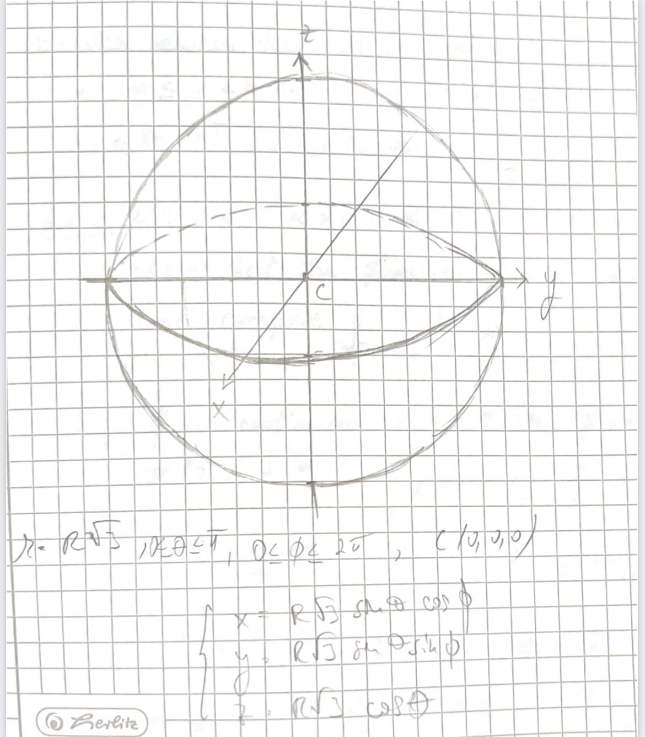

**Solution:**

r(t) != 0 for all t => r(t) is never the zero vector

r(t) · r’(t) = 0 means that r(t) is orthogonal to its position vector r(t) at each point on the curve 𝓒

Because of r(t) · r’(t) = 0, the curve 𝓒 moves in such a way that the position vector r(t) is always perpendicular on the tangent vector r’(t) at each point along 𝓒 => 𝓒 may be part of a spherical path

The point r(0)=(R,-R,R) may be a potential center for a sphere.

To show that r(t) is always on a sphere, for all possible values of t, we need to show that the distance between r(t) and some fixed point c (in space, where c does not depend on t) is constant. this c will be the center of our sphere. So, we need to show that the distance ||r(t)-c|| is constant (in time)

< = > this is equivalent to showing that ||r(t)-c||^2 is constant (in time)

Given the condition in the hypothesis, we might want to consider c = (0,0,0), the origin of the sistem. Therefore we want to try to prove that ||r(t)-(0,0,0)||^2 = ||r(t)||^2 is constant with time

However, we can write ||r(t)||^2 = r(t) * r(t), where "*" is the dot product.

You can regard f(t) : R -> R , f(t) = r(t)* r(t) as a real valued function

The derivative of this function is f'(t) = r(t) * r'(t) + r'(t) * r(t) = 2 r(t) * r'(t) (here we used that the dot product of vectors is commutative)

So the hypothesis tells us that f'(t) = 0 for all t., and hence f(t) is in fact a constant function

f(t) really represents the distance from the origin (0,0,0) to the position vector r(t). this is always constant, hence r(t) really moves on a sphere centered at the origin.

In order to determine what is the radius of this sphere, it is enough to see "how far" is r(0) from the origin.

But r(0)= (R, -R, R), hence ||r(0)|| = = R $\sqrt{3}$ so this is the radius of the sphere you are looking for.

We can even derive the cartesian equation of the sphere (centered at the origin), which is

+ + = 3 $R^{2}$